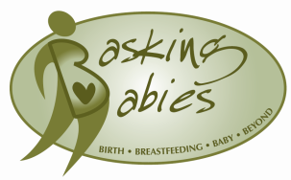

2019 Conference Registration Form
Please fill out the form below. Payment must be received to confirm your registration. If choosing to mail the form (rather than e-mail), please mail to:
Basking Babies, LLC
5050 NE 38th Ave.
Des Moines, IA 50317
Name ______________________________________Phone ____________________________
Address (inc. city, state, zip)______________________________________________________
Email _________________________ Nursing License # ___________________
IBCLC #________________________ Other licenses for CEUs: ___________________________
Do you have a side business? This year we are offering a vending table option to our attendees only. You can make money for your side business all while receiving CEUs and learning valuable information on breastfeeding! The only requirement is that it be International Code of Marketing of Breastmilk Substitutes compliant. Do you sell hand crafted items, do photography, have a lactation or postpartum service, sell Tupperware, Norwex, essential oils, Pampered Chef, baked goods, jewelry, cosmetics? Anything goes as long as it is code compliant.

E-mail Angela at lactationlady@live.com for more information. Spaces are limited!

REGISTER AND PAY INSTRUCTIONS
Option 1 - Mail this completed form with your payment - $95 cash or check for early bird registrations (before October 7th) or $110 October 7th or after. Payment and registration form must be received before October 7th to receive the early bird rate. No refunds will be given.
Option 2 - E-mail (lactationlady@live.com) this completed form and pay by PayPal online at the bottom of the webpage: http://www.basking-babies.com/2019-conference-registration.html

When e-mailing, please make "2019 Conference" your subject line and include the email address linked to your PayPal account in the body of the message.

