2017 Conference Registration Form
Please fill out the form below. If choosing to mail the form (rather than e-mail), please mail to:
Basking Babies, LLC
5050 NE 38th Ave.
Des Moines, IA 50317
Name ____________________________________________________________
Address (with city, state, zip)___________________________________________
Phone ____________________________ Email ____________________________
Nursing License # ___________________ IBCLC #__________________________
Other Licenses with numbers to which you would like Continuing Education Credit:
_________________________________________
__________________________________________
REGISTER AND PAY INSTRUCTIONS
Please do one of the following:
Option 1 - Mail this completed form with your payment - $85 cash or check for early bird registrations (before October 9th) or $95 after October 9th .
Option 2 - E-mail (lactationlady@live.com) this completed form and pay by PayPal online at the bottom of the webpage: http://www.basking-babies.com/2017-conference-registration.html

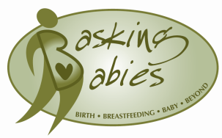
When e-mailing, please make "2017 Conference" your subject line and include the email address linked to your PayPal account in the body of the message.

